**Q. Any Colour is made up of three primary colours Red, Green and Blue. Red colour has zero Green and zero Blue in it. Red can be classified into brightest, dark and light based on its intensity (expressed as percentage) in RGB. If the intensity is greater than 50 and less than or equal to 100 then we say it as brightest. It is said to be dark when the intensity is greater than 25 and less than or equal to 50 and light otherwise**

**Boundary Conditions – Intensity >= 0 and Intensity <=100**

PAC

|  |  |  |  |
| --- | --- | --- | --- |
| **Data** | **Processing** | **Output** | **Solution Alternatives** |
| Intensity | If 50 < Intensity <= 100  Print Brightest  If 25 < Intensity <= 50  Print Dark  Else  If Intensity <= 25  Print Light | Print Output |  |

Algorithm

* Start
* Use variable **Intensity**
* Read **Intensity**
* if (**Intensity** > 50 and **Intensity** <= 100)

Print Brightest

elseif (**Intensity** > 25 and **Intensity** <= 50)

Print Dark

elseif (**Intensity** <= 25 and **Intensity** >= 0)

Print Light

else

Print Intensity should lie between 0 and 100

* Stop

Flowchart

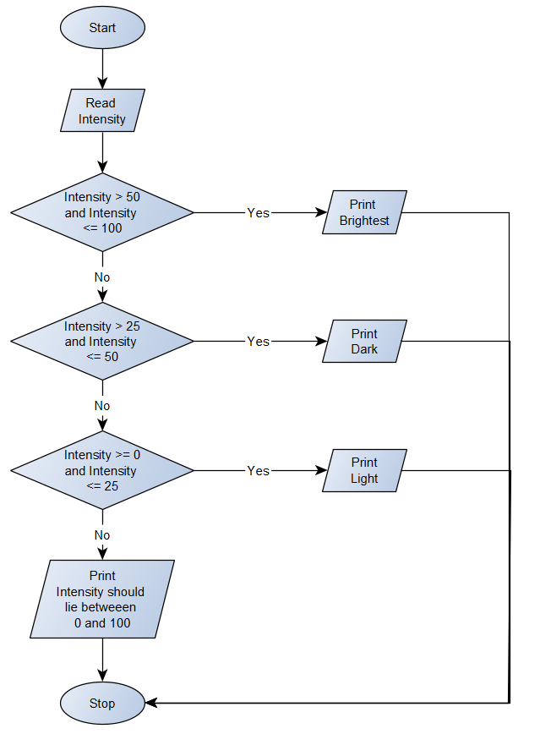

Python Program

Intensity = float(input(**"Enter the intensity of Light : "**))  
if (Intensity > 50 and Intensity <= 100):  
 print(**"Classification : Brightest"**)  
elif (Intensity > 25 and Intensity <= 50):  
 print(**"Classification : Dark"**)  
elif (Intensity >=0 and Intensity <= 25):  
 print(**"Classification : Light"**)  
else:  
 print(**"The intensity of light should lie between 0 and 100"**)